I gratefully appreciate the performance of APR Construction Solutions, Golaghat regarding my house building designing, planning and supervising in pros and cons throughout the construction steps.

I wish its continued success and prosperity in all its ventures in future.

Thanking You

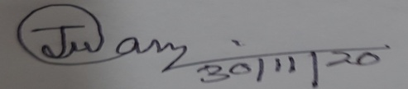

(Dr Jadumoni Das)

Court Road, Golaghat